**Task 1  
  
Project 1**  
  
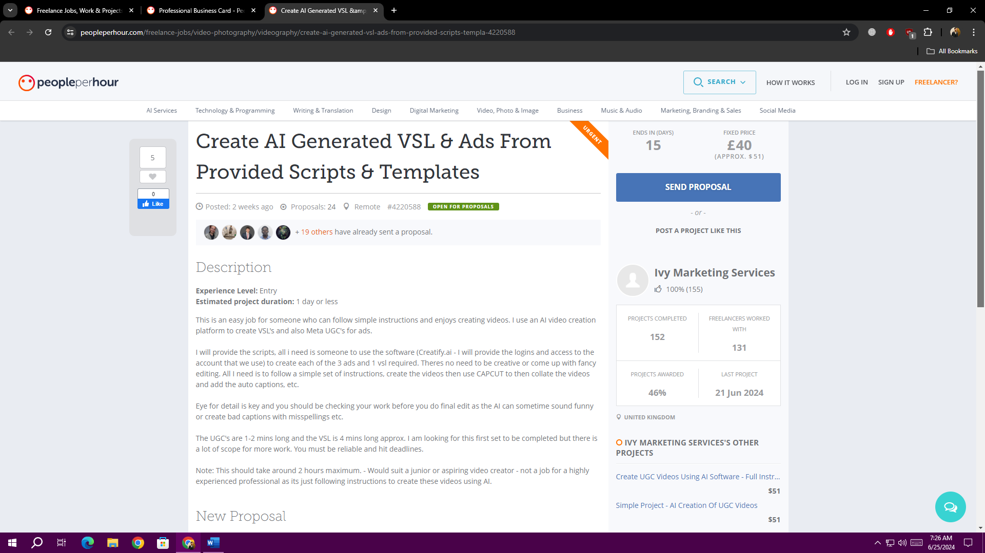  
  
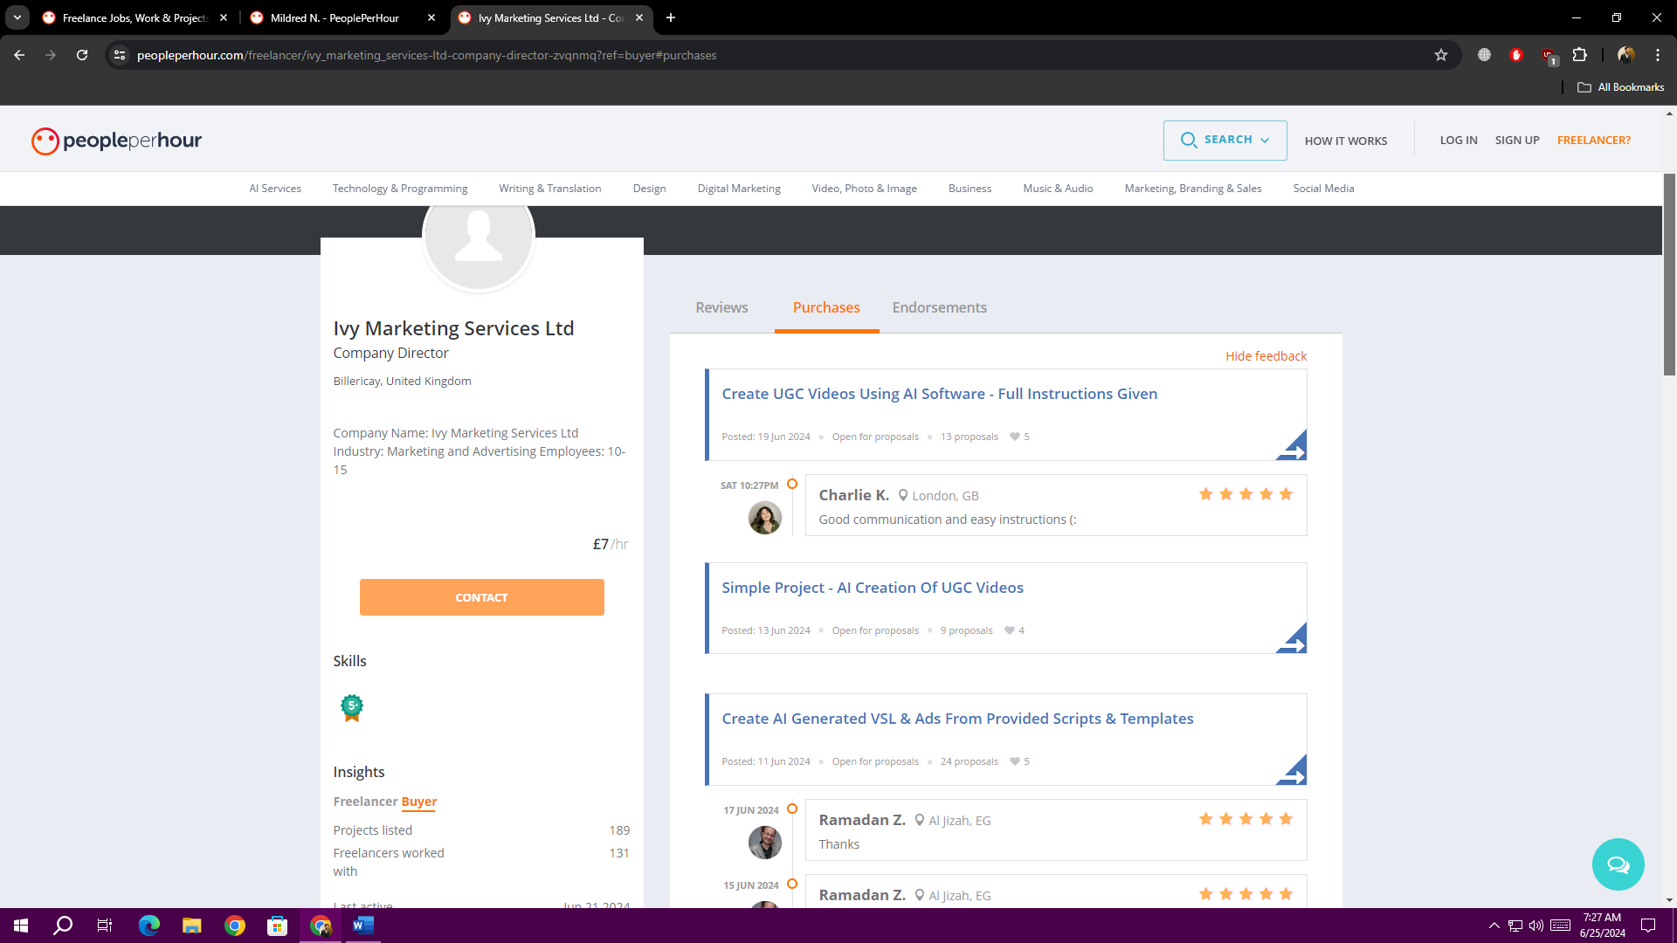  
  
**Project 2**  
  
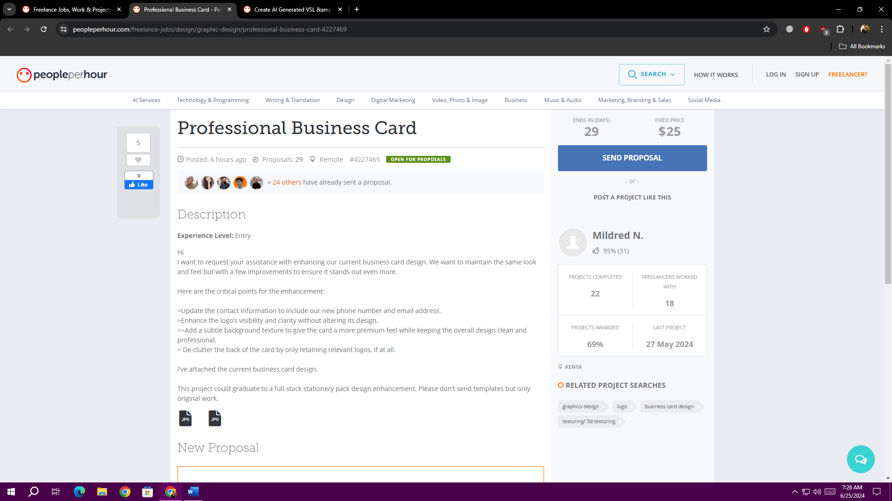  
  
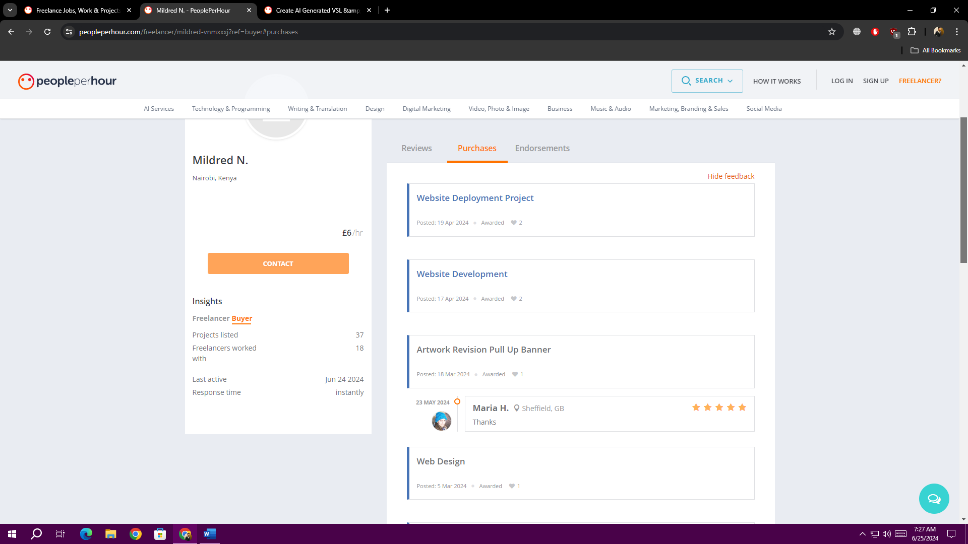

**Task 2**

**Cover Letter for Jannat Suleman - Creatify.ai VSL & Ad Creation**

**Dear Hiring Manager,**

My name is Jannat Suleman, and I am writing to express my keen interest in the "Create AI Generated VSL & Ads from Provided Scripts & Templates" position at Creatify.ai. I was particularly drawn to this opportunity as my skillset in following clear instructions and my experience in freelance video production perfectly align with the requirements you've outlined.

I have developed my skills as a freelance agent over the last two years by collaborating with customers to produce excellent video content in accordance with their particular requirements and specifications. I am good at paying close attention to directions and I know how important it is to follow pre-made scripts and templates.   
I've gained the abilities I need to succeed in this position thanks to this experience, and I can use Creatify.ai's platform to produce excellent VSLs and advertisements for your clients.

With my background in freelance video production and my ability to follow directions accurately, I'm sure I'll be a great addition to your team. I'm excited to find out more about Creatify.ai and how I can help you keep being successful.

Thank you for your time and consideration. I have attached my resume for your review and look forward to the opportunity to discuss my qualifications further in an interview.

**Sincerely,**

**Jannat Suleman**